Behavior Database
TIE 533 Final Benchmark

Megan Meade
National Louis University
May-June 2012

Introduction
Saint John Berchmans is a Catholic pre-kindergarten through 8th grade school located in the Logan Square community in Chicago. I have been working in this school as a pre-kindergarten teacher for two years and have never felt that our data collection and analysis has been up to par with regards to all sorts of data including assessment, behavior, and administrative. Because we are a Catholic School, we collect very few assessment records with data limited to standardized ‘Terra Nova’ scores for grades one through eight and ‘Children’s Progress’ scores for pre-kindergarten and kindergarten. Our entire school consists of approximately 250 students, 90 of them being in pre-kindergarten. Instead of working with the minimal assessment data collected, I chose to focus on behavioral data instead. I have recently been asked to be on a new committee at my school called "Restorative Justice." We had our first meeting about two months ago and have been working at adopting this program ever since. Restorative Justice is "...a theory of justice that emphasizes repairing the harm caused or revealed by criminal behavior. It is best accomplished through cooperative processes that include all stakeholders" (restorativejustice.org<http://restorativejustice.org>). It is our goal over the next several years to completely change and revamp the behavior policies and behavior system at our school. The Restorative Justice Program is not so much about discipline, as it is restoring the peace and mediating between all parties involved. Our school will be changing from a punitive system to a problem solving/mediating approach. I am excited about this new program and the opportunity to be on this committee. Since there are currently only 4 teachers and the principal on the committee, we have been doing most of the work to get the program started off on the right foot.

Part One: Behavioral Data Management Practice
Before creating the database tool, I was able to interview the following faculty at St John Berchmans in order to see where our school is lacking in data collection, analysis and decision making. I tried to interview teachers of various grade levels, but most of the teachers did not have free time to answer a few questions. The interview questions are different for the principal, Peggy Roket, then with the other three teachers. I have color coated the interviewees and their responses to the following interview questions:
- Peggy Roket: Principal
- Jenny Peters: Preschool
- Michelle Thompson: 7th Grade
- Elizabeth Burke: Kindergarten
Interview with Peggy Roket:
- What is your name and title?

Peggy Roket, Head of School

- How are student behaviors tracked at St John Berchmans? If there is no school-wide system, would you be interested in a behavioral tracking system?

Student behaviors are tracked by individual teachers. Some use a binder system, based on the Kanter model of discipline – the binder is supposed to travel with the class so individual teachers can keep track of discipline throughout the day. Some teachers track discipline in our student management system, RenWeb, which has the ability to document and track behavior incidences. In addition, this system has the capability to email parents, counselors and administrators to make them aware when an incident is recorded. It also can print reports at the intervals in the year documenting a full behavior record for an individual student.

Yes, I would be interested in a school-wide system.

- Why is SJB moving towards a restorative justice program? Can you briefly explain what this is?
I like that the approach to restorative justice is less punitive and more preventative. At its
simplest level, restorative justice is a model that teaches students how their behavior
impacts their community, how to repair the community when misbehavior occurs,
and how to establish learning environments and a school climate that prevents
discipline issues.

- If a database was created, what would your school plan on doing with behavioral information that is input into the database and then analyzed? How would it be used to benefit the school and its students?
We would use it in much the same way we use academic data – both to understand and address behavioral challenges of individual students and to adapt our whole-school approaches to discipline based on the needs of our student body.

- Would you prefer that the database allow parents access to their child’s behavioral report on a daily basis?
Yes

- Are you opposed to a color behavior system on the database? See sample chart below.
No.

- Are you willing to offer professional developments to teachers who are new to inputting information into a database and analyzing this data?
Yes.

Interview with teachers:
- What is your name and title?
Jennifer Peters – Pre-Kindergarten Teacher
Michelle Thompson (7th Grade homeroom teacher, 6th-8th grade math teacher)
Elizabeth Burke Kindergarten Teacher
- How many years have you been teaching at St. John Berchmans?
Two
Three
One
- How do you feel St John Berchmans is doing in regards to the behavior data collection and analysis of its students?
As a whole school, it is not very organized. Each teacher or class does its own thing regarding punishments. Even among classes of the same grade level, like pre-kindergarten, there are differences between behavior management and documenting specific behaviors. There is not a school-wide system to follow.
Ok. I personally do not document every incident that happens in my room, and do not spend time analyzing it.
There is currently no school wide system in place. I think the steps being taken by the DePaul students and the Restorative Justice group are a good start, but we have lots of room for improvement.
- Currently, how do you keep track of the behaviors in your classroom? Please explain in detail.
I have a behavior binder that keeps track of behaviors. The binder consists of a list of the students in my class with a table to record their behavior each day. A student can get a warning for being disrespectful, hitting another child, not following directions, etc. A warning gives the child a checkmark next to his or her name for the day. If the student gets three checkmarks in a day, his or her parents are emailed about the specific behaviors that were inappropriate for school that day.
I have a behavior binder that travels to each class with my students. They each have a sheet, labeled with the categories of verbal warning, away from the group, away from the class, detention, and principal. If it is a serious issue, it also gets written down in our online database RenWeb.
Our class uses a colored card system to help students monitor their behaviors during the school day. The purpose of this system is to:
- help maintain a classroom atmosphere conducive to learning
- help students learn to take responsibility for their actions
- allow for weekly communication about each child’s classroom behavior with parents

Here is how it works:
There are four cards in each child’s pocket: green, yellow, blue and red. Each day, all children begin with on green.
A green card indicates the student demonstrates appropriate behavior and follows the classroom rules. (Green cards are great!)
If a child is having difficulty following rules the student will have to turn their card to yellow. Yellow signifies the need to slow down and think about their actions.
If he/she continues to have difficulty following the rules they will turn their card to blue. A blue card means the child will be removed from the group for five minutes to cool off, and think about how they need to change their behavior.
If the child still is not following the rules they must turn their card to red. They will lose their recess/ playtime and a Behavior Plan note will be sent home for you and your child to complete together.
- What are the consequences for student misbehaviors?
Students usually have to sit out of an activity for misbehavior like not following directions or being disrespectful. If a student has harmed another student, both students have to talk to the teacher about what happened and then apologize to each other. If student behavior is really out of control and they get three warnings in a day, parents are emailed.

Note/phone call home, detention, silent lunch, suspension, or miss out on a fun class activity
(Described in detail in question 4)
- What do you do with the information collected? (Email/call home, input into the computer/RenWeb, throw it away after a week, nothing at all, etc)
If a child receives three warnings in a day, parents are emailed. Otherwise, I just keep the binder in the classroom as a reference for myself. At any time I can look back through the year and see how many warnings each student has and what kinds of patterns are present in misbehavior. I can also use this information as documented evidence if I have a meeting with parents or at parent teacher conferences.
Depending on the incident, either a note or call home, leave the information recorded in the binder, or place a description in RenWeb.
We record the color each child ends the day on every day. At the end of the week we send home a weekly reflection to be signed and returned on Monday. (I will attach a copy to the email.)
- Has this behavior tracking system changed since you started working at St. John Berchmans?
No, I have done this for two years.
No. We changed the look of the sheets in the binder, but the idea was the same.
No.
- In order to better collect and analyze behavioral data, a school-wide database is necessary. It would be the responsibility of the classroom teacher to input all behavior data each day into the database. Input information would include student’s name, date, behavioral level, description of incident, and resolution. Would you be interested in a school-wide database behavioral tracking system? If so, why?
Yes, because it would greatly increase the consistency of behavior management. In higher grades, teachers would not have to explain the system to students every year in great detail because students would already be used to it from the previous year. Students would know what to expect in terms of consequences for misbehavior and would already know what is expected of them. It would also be good for parents to see what behavior issues come up in the classroom on a daily basis so that the issue can be addressed at home as well.
Yes. However, I think it would need to be something very simple and quick, otherwise I don’t think that each teacher would devote the time to completing the report each afternoon.
Yes, I think that it is important of us to look at the areas where we are succeeding and areas we may need to improve upon. It would be helpful not only for me in my own classroom to have the data organized but also as a school we could look at specific behaviors, and/or areas of the school (hallways, lunchroom, recess) where we could improve.
- Is there anything else you could think of that should be included in this database?
I think teachers should be able to see data of students from previous years. That way, they can spot patterns in behavior more quickly and be able to address problems right away.
Possibly if home was contacted either by phone call, discussion after school, or email. That way there is record if it becomes a reoccurring issue or if they seem to not know of behavior patters of their child.
We have infractions coded in our room to put next to the color the child ended the day on. For example T- talking, N- not following directions, ect. Maybe if there were a simple code to help teachers speed the process of entering data they would be more likely to follow through.
- The behavioral level would be chosen from a drop down menu with four color choices. See sample behavior chart on the next page. Would this be something that you would use with each individual student in your class on a daily basis?
Yes, with the descriptions of behavior in each level, it would be easy to evaluate how serious a student’s behavior is.
I think the idea of it is great. I do think the section items would need to be extremely specific, especially when working with my older kids. I also think it would need to be age related, as they have all classified the “stoplight” system with the preschool and kindergarten years. In order for it to be successful, they would also have to buy into the new system.
Yes. This is similar to the system we already have in place and instead of keeping track on paper we could easily switch to the database.
- Do you keep track of the positive behaviors in your class and reward the students who do something positive? If so, how?
Yes. When students are seen doing something really helpful without being asked, they are given a star sticker. Stars are a big deal because when a student get one, he or she is recognized in front of the whole class as being a good helper. If a student receives three stars, he or she gets a special prize (a certificate and a pencil or something small) to show that the class appreciates them being helpful all the time.
Each student can earn a homework pass for each week they are not written down in the behavior binder. The class can earn a party or special snack for continued positive behavior.
We keep track of positive behaviors and rewards as a whole class by using a “Warm and Fuzzie Jar” similar to a marble jar. We also give individual students tickets for positive behavior. They are able to then trade their tickets for small prizes in the treasure box.
- Would you be willing to attend a professional development workshop that explains this database, how it will be used, and what information will be gained from it?
Yes, definitely.
Yes.
Yes.
Table of St John Berchmans Current Behavioral Data Collection
Type | Grade Level
None | Preschool 1
Green/Red Circle Daily | Preschool 2
None | Preschool 3
Behavior Binder/Star Chart/Green/Red Circle | Preschool 4
Weekly Color Behavior Calendar | Kindergarten 1
Weekly Color Behavior Calendar | Kindergarten 2
Behavior Binder | 1st
Behavior Binder and Sticker Chart/ Warnings | 2nd
Behavior Binder | 3rd
Behavior Binder/RenWeb Report Manager | 4th
None | 5th
Behavior Binder | 6th
Behavior Binder/ RenWeb for severe consequences | 7th
Behavior Binder/ Modified behavior binder with tallies for unacceptable behavior | 8th

Current Behavioral Analysis Tools
Currently, at Saint John Berchmans, there are no behavioral analysis tools being utilized. Our school does have a feature on RenWeb which allows teachers to input daily behavior reports for each student, but only includes the student’s name, the date and the behavior type. “RenWeb is a school management system that provides a web interface for many common tasks done by schools.” (http://www.renweb.com/). Only two teachers utilize this feature just as an organized way for them to keep track of the student’s behaviors in their class. It does not offer the features included in the database that I have created, nor does it allow parents to access the information.
Description of Responsibilities of Staff

Administrators: Use data to determine patterns and trends of students

Teachers: Collecting data in database; creating behavioral reports for parents and themselves

Description of How Data Analysis is Reported

Currently, since there is no school-wide behavioral tracking system, there is no analysis and thus nothing to report. Any trends would simply be ones noticed by teachers over the course of a year.

Application to Instructional Planning and Practice

Individually, classroom teachers use their own behavior system to self-assess and manage their discipline practices. As would be expected, this varies from classroom to classroom depending on how much data the teacher collects.

Part Two: Data Management Tool
Description of Behavioral Data Management Practice the Tool Supports
For my final benchmark assignment, I have created a database that allows for teachers at my school to easily input information regarding behaviors and misconduct. Each day, the teachers would input data into the database including the student’s name, date, location, behavioral level, description of incident, resolution, and suggestions for further action. On the database, the teacher will have the option to include any mediating sessions, circle times, etc that occurred throughout the day. This is a great way for the teachers to keep track of what their students are doing. It is up to the teacher to determine how often he or she will send reports home. Some teachers would prefer to send weekly reports, while others may choose to send daily reports depending on the situations that arise. On these reports the parents would then be able to see how the situation was handled in the classroom, so as to handle it in a similar way at home. Currently, there is no school-wide behavioral system and many teachers do not have a behavioral plan at all. Our principal is hoping to get all teachers on the same page by the beginning of next year and I am confident that my database will lead us in the right direction.
This database would be set up on the school network in order for all teachers to have access to it. Each day, the teacher would have the option to either input a behavioral level for each child or just for the students who misbehaved. Inputting behavioral data for each child every day would be helpful for the teacher when analyzing patterns or trends in the classroom. This behavioral level would consist of a five step behavior color system to visually represent different types of misbehaviors or infractions. There would also be a color (purple) for excellent behavior where a student exceeds expectations or is seen helping a friend. This would allow for teachers to record positive behaviors in the database as well. This data could then be compiled into charts or graphs at any time to see trends or patterns of students. If the student continued at St John Berchmans, the data could be compiled into charts and graphs over the course of their schooling to see larger trends and patterns. I feel that all teachers (and parents) would benefit from this database. Recording behaviors and mediations would work in all grades (prek-8) and would be a great technological addition to Saint John Berchmans.
Tool’s Construction (including samples)
The tool was constructed through the use of Microsoft Access. I started with a database of the students at a school. This contained the students’ names, teachers, grade levels, address, contact information, etc. Initially this list was filled in through the table itself, but I also created a form for ease of use in entering data. This database would theoretically be filled at the beginning of the school year and whenever there is a new student or a change of information. A screenshot of this form is below.
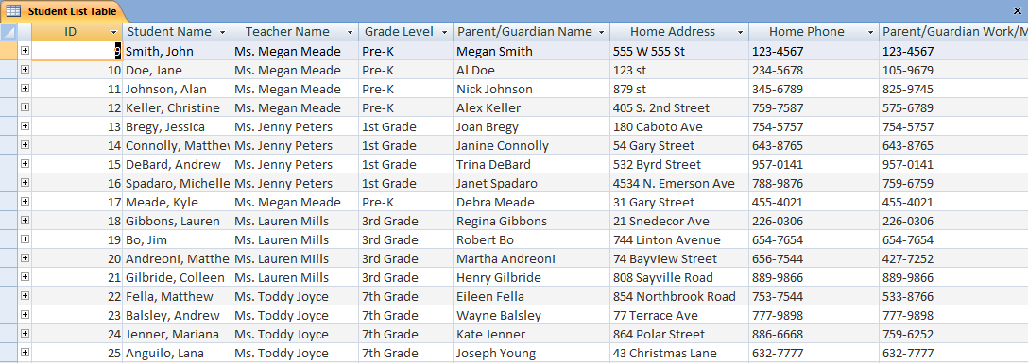
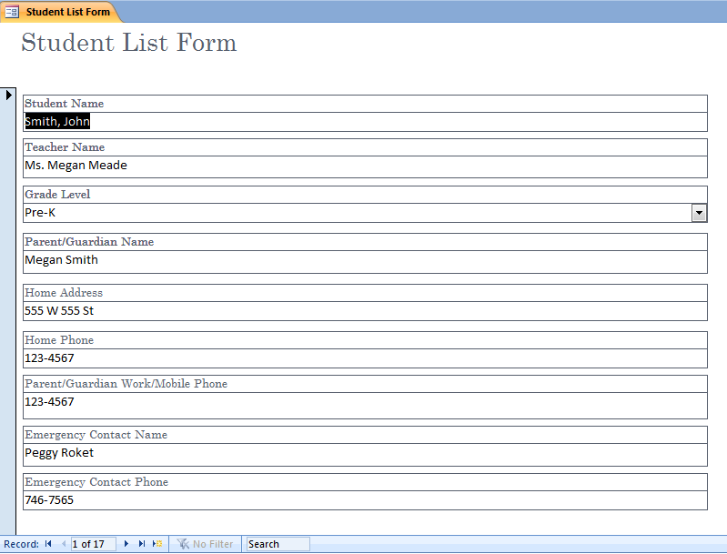
The next step was to create a database of incidents. Each incident is linked back to one of the students in the Student Database. For each incident a teacher would enter the incident date, location, behavior level (according to the color coded system below), description of the incident, resolution of the incident, and any suggestion for further action on the part of the school or parents. The color coded chart would be used school wide and provides a list of offenses or misbehaviors for each column, as well as columns for positive behavior and excellent behavior. The students would be knowledgeable about this system and the charts could be posted throughout the school to remind the students of the behavior levels. This database is also filled through the use of a form.

Exemplary | Ready to Learn | Level 1 | Level 2 | Level 3
-Made good choices and helped others | -Followed all rules and expectations  -Made safe and responsible choices | -Interrupting teacher or fellow student  -Displaying anger or frustration inappropriately  -Used negative actions or words  -Showing disrespect towards teacher or another student | -Repeated level 1 behaviors  -Showing physical aggression  -Inappropriate language  -Making unsafe choices  -Not following school rules  -Dishonesty | -Repeated level 2 behaviors  -Stealing  -Vandalism  -Violence  -Threats

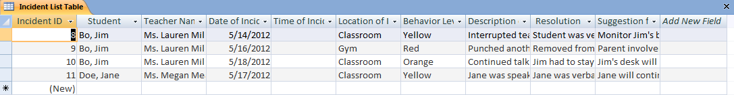
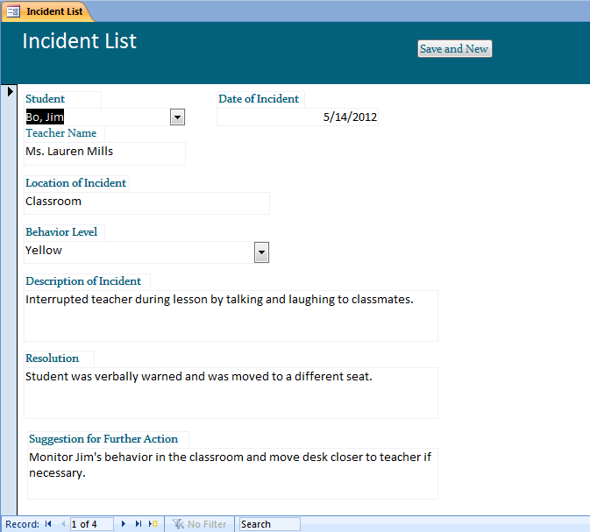

Once the incident database has been filled, the next step is to create a way to run reports on the incidents. This would make it easier to keep track of discipline in the classroom and notice any trends in student behavior. The most useful type of report for our purposes is a list of incidents for one student. This could be sent to the parent at the end of each week to keep them informed of their child’s behavior at school. Initially it looked very complicated to set up this report, but after reading “Using parameters with queries and reports” by Sal Ricciardi, I was able to run my report successfully.
The first step in setting up this report is to run a query, and define certain parameters on which to base the query. In my case the two parameters are Student Name and Incident Date (using a user-defined range). Once this query was set up, I created a form to input the necessary criteria into the query. Using an OK button placed on the form, I was able to run the query and show the results automatically once the data was entered. Once this was completed, I created a report that used the already-created query as its Record Source. Using a little bit of coding, I was able to make Access open the input form upon the opening of the Report. The user then enters this information into the form, which provides the parameters to the query, which provides the relevant information to the Report. These steps can be seen below.
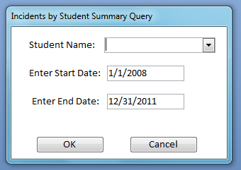

Tool’s Application to Sample Data (including samples)
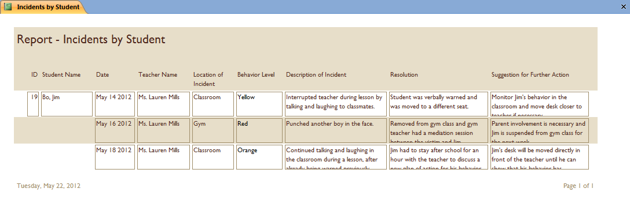
In order to demonstrate the tool’s functionality, I created a sample list of fictional students at various grade levels:
Then I entered a number of incidents for a few students, including multiple incidents for one particular student, Jim Bo. This information was entered as shown below:
Next, assuming that I wished to send a list of Jim Bo’s incidents over the course of the week to his parents, I ran the relevant report. Entering the student’s name (Bo, Jim) and the start and end date for the week (5/14/2012-5/18/2012), the tool produced the following report:
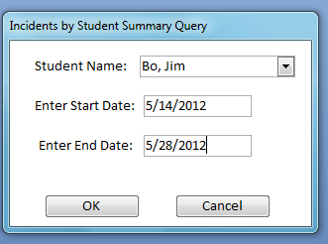

Intended Use of the Tool in Relation to Other Current Practice
This behavioral database tool was designed specifically for my school, Saint John Berchmans. As I have previously mentioned we currently do not have a school-wide behavior system, but are in the works of adopting a Restorative Justice Program. This program moves away from a punitive approach, and more so focuses on conflict resolution and mediation. Students that reflect on their behavior and have deeper consequences involving their parents, the victim, the victim’s parents, or the teacher will hopefully be more likely to change their behavior and not make the same mistake twice. The Restorative Justice program does focus most of their ideas on conflict between students or conflicts between the teacher and a student, but it can be reworked to include all forms of misbehavior. For instance, if a child in a kindergarten class is laughing and talking while the teacher is teaching a lesson, this is a good opportunity to have circle time discussion about his or her behavior. The class will have the opportunity to speak out about how this child’s actions are affecting their learning and the child will be able to apologize to the teacher and the class. It is imperative that teachers take the misbehaviors of students and use them as a learning opportunity.
Our school is in need of one set program that will be carried out by all teachers year to year. The consistency will not only benefit the school and the teachers, but the students will know year after year what is expected of them and how misbehavior incidents will be handled. The behavior database I created will be the first step towards our school wide behavior change. If each teacher is onboard to input and follow through with student misbehaviors each day, this system will be able to grow into something big. Teachers will be able to access the database through the school network and will be able to see the student behaviors over the course of their time at St. John Berchmans. The reports will be able to show patterns and trends and the teachers will be able to work with this information. This can help teachers make decisions that will preemptively discourage students from misbehaving. The teachers will have access to all student information and this will help alleviate any issues that may arise. For example, if the teacher knows the Billy has a tendency to use violence in the classroom, he or she will place Billy’s desk close to the teacher’s at the beginning of the year.
This information will also be helpful during parent meetings or parent-teacher conferences. Reports over the course of the year or years can be printed out or emailed to show the parents their child’s behavior patterns. The teacher will be able to show the parents exactly who, what, when and where the incident occurred and how it was handled. The parents can then follow through similarly at home and ensure that the student is receiving a consistent message at all times.
Review of Tool’s Effectiveness Described by a Potential User (including recommended changes)
I asked my co-teacher to evaluate my behavior tracking tool for this particular section. Here is her response:
“This school-wide behavior database is a great idea for our school. I love the idea of having a place to store all of a student's behavior issues in one place on a school network. This information will make it easier for teachers to see patterns in behavior and correct them efficiently. Though some teachers may be intimidated by the new tool, I think one really good professional development meeting will get everyone excited about it. “ –Jenny Peters
One idea that she also recommended was creating a site that would allow parents to access their child’s behavior reports on a daily basis instead of having the teacher print off behavioral reports on a daily or weekly basis. I really like the idea of this, but would probably need a whole other ten weeks to complete this.

