Problem-Based Mini Unit
Megan Tennant
TIE 512: Fall 2012

Endangered Animals Need Our Help!
Introduction
Some animals are endangered because they lack basic needs for survival such as habitat, food and water, and shelter. These are very similar to the basic needs of human beings. Other reasons for the endangering of animals are climate changes, disease and illness, pollution, destruction of habitats, and hunters. Children are taught from a young age about different kinds of animals by reading books, watching television, and in their schooling. Some of the animals that these children are learning about are becoming endangered or extinct. This mini-unit is a problem based learning unit, in which students will learn about endangered animals and come up with ways to save the lives of the ones in need.
Aim

In this four week mini-unit, students will gain a better understanding of endangered and extinct animals and the ways they can help save endangered animals.
Rationale

In this PBL lesson, students will study the facts about endangered and extinct animals in the United States. The students will learn the reasons behind endangered animals and will be faced with the problem of figuring out ways that people could help the animals in need. This unit is important for students because it allows them to learn about the basic needs of all living things. The problem based learning approach allows the students to feel empowered and know that they can make a difference in the world (even if it means raising money to save one animals’ life.) By allowing the children to learn of the many endangered animals throughout the United States, I hope that someday they will try to protect animals from becoming endangered and even extinct. This unit integrates science, math, art, and technology while using and practicing various skills such as problem solving, critical thinking, and modeling.

General Instructional Goals

- Students will:
  - Develop concern and an overall awareness about endangered animals
  - Understand the reasons behind animals becoming endangered and extinct (lack of basic needs, environmental issues, disease, etc)
  - Understand various ways to help endangered animals
  - Identify and model a complex system: Create collages of habitats of the endangered species.
  - Collaborate with students in groups to brainstorm various ideas
  - Utilize technology

Learner Description
This four week mini-unit is designed for kindergarten students and explores the topic of endangered species. It can easily be adapted for other grade levels since “animals” is a basic topic that is widely covered in school. This unit will also be accommodating to different types of learners. The subject matter will be discussed orally, as well as shown visually on the Promethean board. Pictures and picture books of endangered and extinct animals will be provided for the visual learners. Various aspects of the unit including artwork (collages and voting cards) and math (sorting votes, counting votes, and counting money) will work best for those who learn kinesthetically. The teacher will always be available to help students, but will encourage learning on their own.
Modifications for learners with special needs:
- Additional time for skill mastery
- Peer assistance provided
- Pre-formed groups
Prerequisites

Students will have studied animals and the basic needs of animals in preschool and in kindergarten prior to this unit. Before beginning this unit, students should be able to:
- Explain how an animal is different from a human being.
- List the basic needs of animals.
- Write and recognize all letters of the alphabet.
- Write words and sound out spelling of words they do not know.
- Show knowledge of basic computer skills (use of mouse, keyboard, etc)
- Work cooperatively and collaboratively in a group
Subject-Matter

The subject matter of this project based mini unit involves research, investigation, problem solving, and modeling. The topics covered will include:
- Science:
  - Difference between endangered and extinct animals
  - Basic needs of animals and basic needs of humans
  - Habitats
- Math:
  - Sorting
  - Counting money
  - Addition
  - Graphing
- Technology:
  - Group research on computers with teachers’ assistance
  - Voicethread presentations
- Art:
  - Following specific directions to create voting cards
  - Collage of habitats of endangered species
- Language Arts:
  - Oral presentation skills
  - Writing skills
- Other:
  - Persuasion
  - Collaboration

Standards

Illinois Learning Standards for Kindergarten

Science

State Goal 12: Understand the fundamental concepts, principles and interconnections of the life, physical and earth/space sciences.
- Learning Standard A: Know and apply concepts that explain how living things function, adapt and change.
  - BENCHMARK 12.A.Ka Observe, categorize, and describe characteristics, basic needs, and life cycles.
- Learning Standard B: Know and apply concepts that describe how living things interact with each other and with their environment
  - BENCHMARK 12.B.K Describe and compare basic needs of living things.

Language Arts

State Goal 4: Listen and speak effectively in a variety of situations.
- Learning Standard B: Speak effectively using language appropriate to the situation and the audience.
  - BENCHMARKS 4.B.Ka Use language to communicate needs and wants.
  - 4.B.Kb Use expanded language and vocabulary for a variety of purposes.

State Goal 5: Use the language arts to acquire, assess, and communicate information.
- Learning Standard A: Locate, organize and use information from various sources to answer questions, solve problems, and communicate ideas.
  - BENCHMARK 5.A.K Seek answers to questions through active exploration.
- Learning Standard C Apply acquired information concepts and ideas to communicate in a variety of formats.
  - BENCHMARK 5.C.K Use discussion, drawing, writing, or other means to communicate new information learned.

Mathematics

State Goal 6: Demonstrate and apply a knowledge and sense of numbers, including numeration and operations (addition, subtraction, multiplication, division), patterns ratios, and proportion.
- Learning Standard B: Investigate, represent and solve problems using number facts, operations (addition, subtraction, multiplication, and division) and their properties, algorithms, and relationships.
  - BENCHMARK 6.B.Ka Solve simple math problems mentally, or by using objects, drawing pictures, etc.

NETS Standards
1. Creativity and Innovation: Students demonstrate creative thinking, construct knowledge, and develop innovative products and processes using technology.
a. Apply existing knowledge to generate new ideas, products, or processes
b. Create original works as a means of personal or group expression

2. Communication and Collaboration: Students use digital media and environments to communicate and work collaboratively, including at a distance, to support individual learning and contribute to the learning of others.

a. Interact, collaborate, and publish with peers, experts, or others employing a variety of digital environments and media
b. Communicate information and ideas effectively to multiple audiences using a variety of media and formats

4. Critical Thinking, Problem Solving, and Decision Making: Students use critical thinking skills to plan and conduct research, manage projects, solve problems, and make informed decisions using appropriate digital tools and resources.

a. Identify and define authentic problems and significant questions for investigation
b. Plan and manage activities to develop a solution or complete a project
c. Collect and analyze data to identify solutions and/or make informed decisions

Learning Objectives
Driving Question: How can we help animals in need?
- Students will be able to:
  - Successfully understand how to use multiple types of problem-solving strategies in order to accomplish a goal.
  - Work collaboratively and cooperatively in a group in order to complete the tasks.
  - Understand the terms endangered, extinct, and habitat.
  - Understand how animals become endangered and extinct.
  - Use technology to create Voicethread presentations.
  - Use art materials to create collage of the habitat of an endangered species.

Instructional Plan
Week 1
Day 1
- Entry Activity: The teacher engages the students in a conversation about animals and basic needs of living things. Then, the teacher will present a short video (http://www.youtube.com/watch?v=EdiDcYkW4lM) about endangered animals and their lack of basic needs. The teacher asks the students what should be done to help these poor animals.
- Essential Questions:
  - What are endangered animals?
  - What is the difference between extinct and endangered?
  - Why do some animals become endangered (and extinct)?
  - What animals are on the endangered animal list?
    - Why are they there?
      - What can we do to help them?
- Discussion: Talk about extinct animals (ex: dinosaurs) Ask: “Have you ever seen a dinosaur in real life? Why not?”
- Using the SMARTboard, research other animals that are extinct as a large group. Watch this short BrainPop video about endangered and extinct animals: http://www.brainpopjr.com/science/conservation/extinctandendangeredspecies/preview.weml
- Activity: Fold your paper in half. On the left side, draw one extinct animal that you learned about. On the right side draw one endangered animal that you just learned about. Label your two animals by sounding out the spelling of the animal name. Have a few children come up to describe their drawings.

Day 2

- Basic needs discussion: “How do animals become extinct?” and “How do animals become endangered?”
  - Hunters and poaches, disease, environmental factors (climate, deforestation, new buildings, loss of habitat), lack of food and water, destroyed shelter, pollution, etc.
- Watch this basic needs of animals video on the SMARTboard:
  - http://www.time4learning.com/_swf/demos/childu/12science_basic_needs.html
- Discuss difference between basic needs of animals (shelter, habitat, food and water) and basic needs of human beings (shelter, clothing, food and water)

Day 3

- Activity: Have students begin the lesson by writing a short (three sentence) journal entry about their feelings towards endangered animals.
- Discussion: Talk about endangered animals and research various endangered animals using the SMARTboard. Watch videos/read information aloud to the students about individual animals that the students choose:
  - http://gifts.worldwildlife.org/gift-center/gifts/Species-Adoptions.aspx
- As a class, narrow down the list of endangered animals to be studied to six. The teacher will then break the class up into groups of six (4 students per animal).
- During centers, the teacher will help individual groups conduct research online and in library books about their endangered animal.
- Homework assignment: Do research at home with your parents about the endangered animal your group is studying. Fill out the homework sheet found below.

Day 4

- Complex Modeling Activity: Individually, create collage models of the habitat specific to the animal your group is researching. The requirements of this collage would be to include all of the basic needs of the animal (shelter, food and water, habitat), as well as at least one threat to these animals existence (pollution, hunters, climate, deforestation, etc). The collage would be made with simple art supplies and pictures from magazines and the computer. The complex model would be assessed with a rubric.

Day 5

- Continue working on complex modeling activity.
- Once completed, the teacher should take digital photos of each collage. (This will be included in the Voicethread presentation next week.)
Week 2
Day 6

- Discussion: Ask the students what can be done to help save the endangered animals.
- Group work: Have students sit with their endangered animal group. Explain to the students the following task:
  - We have decided as a class that we want to help save one endangered animal. We would love to save them all, but our kindergarten class does not have the money or necessary equipment to help each animal. We will do our best, but even if we can save the life of one animal, we still made a difference. As groups, you must collaborate (work together) and talk about your specific animal that has been researched both at school and at home (see homework assignment). You will be creating a presentation on the computer using just your voices and your collages created last week. With the teachers help, the collage pictures and voice presentations will be put together and shown in each classroom of the school, so you have to do your best and work as a team! Each student in the school will VOTE for the animal that they would like to have saved. They will be basing their decision off of the group Voicethread presentations. As a group, you will assign the following roles for the presentation:
    - Brief description of animal
    - Explain the words endangered and extinct.
    - What the animals need to stay alive
    - Ask for help and votes.
There will be a rubric to go along with the Voicethread presentation so make sure each role is covered. If you cannot assign roles within your group, the teacher will do it for you. The group endangered animal with the most votes will be helped in some way by the kindergarten class.
- Group work: Let the groups collaborate and assign roles. The students will start to write out their individual short script.

Day 7

1. Continue to let the students write out their individual short scripts. The teacher will be available to help with spelling, vocabulary, etc. Let the students practice their presentations with their group.

Day 8

- Explain the voting card activity. Individual students need to create voting cards for the student body (1 card per student that will be copied by the teacher). Must include the following:
  - All six animal choices with correct spelling (the animal names will be shown on the board)
  - Space for them to check or X a box
  - Title: “Save the Animals!”
  - Instructions: “Vote for 1 endangered animal to be saved.”
  - Example:
Save the Animals!

Vote for 1 endangered animal to be saved.

Polar bears Gray wolves

Black bears Manatees

Dolphins River Otters

- Let the students practice their presentations with their group. During centers, two groups will create the Voicethread presentations with the help of the teacher. The teacher will add the collage photos to the Voicethread presentations. The other four groups will begin creating their voting card for the school.

Day 9

- Continued: Let the students practice their presentations with their group. During centers, two groups will create the Voicethread presentations with the help of the teacher. The teacher will add the collage photos to the Voicethread presentations. The other four groups will begin creating their voting card for the school.

Day 10

- Continued: Let the students practice their presentations with their group. During centers, two groups will create the Voicethread presentations with the help of the teacher. The teacher will add the collage photos to the Voicethread presentations. The other four groups will begin creating their voting card for the school.
- By now, all of the students should have created one voting card for the student body. The teacher will make a few copies of each to hand out to the classes next week.
Week 3
Day 11

- The teacher will send the Voicethread presentations to all of the classes in the school. The individual teachers will present them that day and the students will vote for the animal that they would like to have saved using the kindergarten student-made voting cards. The votes will be sent back to the kindergarten class.
- Small group activity: The kindergarten students will be asked to sit with their group again. The teacher will hand out voting cards to each group. The groups will first sort the votes by animal and then they will count the votes and keep track on a simple graph.
- The votes will then be combined onto one large graph on the SMARTboard to see which animal the kindergarteners would help save.

Day 12

- The kindergarteners will brainstorm ways they can help that animal. The teacher will keep a running list of the SMARTboard.
- The class may decide to raise money for the endangered animal, whether it be for food, medicine, housing, etc. The students will brainstorm more ideas to come up with a fundraising idea.

Day 13-15

- Advertise the fundraising idea money (bake sale, bracelet sale, trail mix sale, etc) around the school using posters, flyers, etc.

Week 4

Day 16-18

- Have fundraiser to help save the endangered animal.

Day 19

- The students will have raised money by now.
- Small group activity: Give each group some money to add up (mixture of coins and dollar bills). Double check their math.
- Large group activity: Add all six groups totals together to figure out how much money was raised for the endangered animal.

Day 20

- Go to: http://gifts.worldwildlife.org/gift-center/gifts/Species-Adoptions.aspx. This website shows how someone would go about adopting an endangered species from their website. It lists the costs and the gifts that go along with adopting the animal. If the class did not raise enough money, ask the students what they should do next. Leave the ideas up to them. If they did raise enough for that specific animal, the teacher will adopt it over the internet.
- Have students fill out self-evaluation form individually. Read each line aloud to the class and give them time to circle a response.

Materials
- Computer with Internet
- Promethean board with speakers
- Microphone for Voicethread
- Digital camera to upload photos of posters
- Books on endangered animals
- Poster boards (1 per student)
- Animal magazines and pictures for collage
- Paper for voting cards
- Art supplies (marker, crayons, glitter, pencils, construction paper, scissors, glue, etc)
- Graphs for voting card sort activity
- Self-evaluation papers
- Homework assignment papers
- Collage (complex modeling) rubrics
- Voicethread presentation rubrics

Plan for Assessment and Evaluation

- Students will be assessed through observation during the four week unit. The teacher will be looking for group collaboration, problem solving and critical thinking strategies, and leadership.
- The students will also fill out a simple, age appropriate self-evaluation form at the end of week four.
- Students will also be assessed with a rubric based on the creation of their model (a collage of the habitat of the endangered animal that they are researching and studying). The teacher will fill out one rubric per student.
- Students will also be assessed with a rubric based on their group Voicethread presentation.

Sample Model (to be produced by students)

- Art collage of the ecosystem of one endangered animal.
- Complex Model Activity: Individually, create collage models of the habitat specific to the animal your group is researching. The requirements of this collage would be to include all of the basic needs of the animal (shelter, food and water, habitat), as well as at least one threat to these animals existence (pollution, hunters, climate, deforestation, etc). The collage would be made with simple art supplies and pictures from magazines and the computer. The complex model would be assessed with the rubric below.

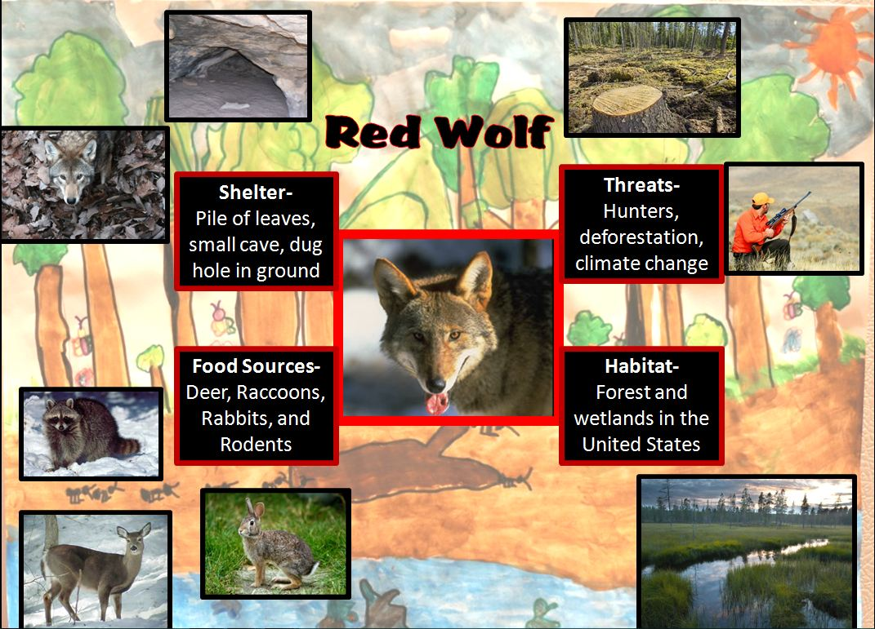
Created by:
Megan Tennant
- Image sources for the sample collage produced by myself:
http://dnr.state.il.us/orc/wildlife/furbearers/raccoon.htm
http://www.statesymbolsusa.org/South_Carolina/DeerWhiteTailed.html
http://www.eparks.org/wildlife_protection/wildlife_facts/redwolf.asp
http://animal.discovery.com/mammals/rabbit/
http://perc.org/articles/contracting-ecosystem-services
http://globeattractions.com/nature-forest-wetlands-water-sky-grass-reflection/
http://russlings.blogspot.com/2009_12_01_archive.html
http://tumbleweedcrossing.blogspot.com/2010_06_01_archive.html
http://mollymoo.ie/categories/kids-drawings/page/2/
http://science.howstuffworks.com/environmental/green-science/deforestation.htm
http://www.destination360.com/north-america/us/utah/utah-hunting
Rubric for Collage
Student Name
Date
Endangered Animal
Habitat (Circle One) | Ocean Desert Wetlands  Forest Other:
Does the collage show…
1. the endangered animal? | Yes (1pt) No (0 pts)
2. the animal’s shelter? | Yes (1pt) No (0 pts)
3. the animal’s food and water? | Yes (1pt) No (0 pts)
4. at least one threat to the existence of the animal? | Yes (1pt) No (0 pts)
5. a neat and creative model of the animal’s habitat? | Yes (1pt) No (0 pts)

This project shows that the student:
6. followed directions. | Yes (1pt) No (0 pts)
7. understood new concepts. | Yes (1pt) No (0 pts)
8. used time wisely to finish project. | Yes (1pt) No (0 pts)
9. wrote name on collage | Yes (1pt) No (0 pts)
10. created a model (collage) of an endangered animal’s habitat using art materials. | Yes (1pt) No (0 pts)
Total Points | / 10

Rubric for Voicethread Presentation
 | Does Not Meet Expectation (0 points) | Meets Expectations (1 point) | Exceeds Expectations (2 points) | Score
Presentation Roles  (Circle One)  1. Brief description of animal  2. Explain the words endangered and extinct.  3. What the animals need to stay alive  4. Ask for help and votes. | Did not fulfill individual role in group. | Fulfills individual role within group with some prompting | Willingly accepts and fulfills individual role in group.
Content- Accuracy | Many inaccuracies due to lack of research skills or effort. | Most of the facts and information in the presentation are accurate. | All facts and information in the presentation are accurate.
Oral Presentation | Mumbles, speaks reluctantly, and/or inaudibly  Speech may be rambling. | Speaks clearly and confidently.  Communicates thoughts  reasonably well and follows a train of thought. | Speaks clearly and confidently.  Communicates thoughts in an organized manner using above grade-level vocabulary
Use of Class Time | Did not use class time to focus on the project OR often were you often distracted by others. | Used some of the time well during each class period. There was some lack of focus. | Used time well. Focused on getting the project done. Never distracted others.
Collaboration within the group | Team members did not work together. | Team members were able to work together, but not everyone had an active role. | The team members worked together with most members contributing equally, and used problem solving skills to come to agreements.
Technological Skills | Cannot explain what a Voicethread is and/or how the Voicethread was made. | Can describe what a Voicethread is and how the Voicethread was made. | Accurately describes and explains how Voicethread was made. Uses technical terminology (mouse, monitor, headset, upload, etc.)
My Self-Evaluation
Endangered Animal Group Project

Name: _________________________________________ Date: ________________________

I feel that with this project, I…

…was a hard worker.
…communicated well with my group.
…was focused.
…understood the project.
…followed school and classroom rules.
…stayed on task with my group.
…did not let my group down.
I think people from my group would like to work with me again.

Endangered Animal Homework

Name: ____________________________ Date: ________________

Why it is endangered?

Type of food it eats
How many are left in the world?

Habitat
Name of animal

